DRUMLINE AND PIT PERCUSSION INFORMATION 2022

Hello everyone and I hope you are all as excited as I am to begin the 2022 season of marching band here at Southeast Guilford High School. As you have no doubt seen, a drumline is a very visual, exciting part of a band program. All band members have a fondness for the drumline, and it is also a fan favorite. It is a vital part of our marching band as it adds elements to the music and marching that you cannot find in other sections. I am excited for your interest in this opportunity and I can’t wait to see what you bring to this season.
As stated in the general Marching Band letter, this year’s band camp will begin on July 28th and will run through August 12th. Thursday, July 28th will be for the Leadership Crew and 9th graders only. Friday July 29th will be for you, percussion/drumline and are mandatory to be a member of the drumline or pit; Colorguard will also be here those days. The rest of the band members will join us on Tuesday, August 2nd. All percussion students, except for those playing Bass Drum will need to order at least one pair of marching sticks through the form included in this packet.
On Friday, July 29th, we will be doing general percussion workouts and auditioning for the various drumline and pit instruments. These instruments include Snare Drum, Marching Tenors (Quints), Bass Drum, Cymbals, and the various pit instruments. You are allowed to audition on multiple instruments, and I encourage you to do so. There may be opportunities at times for you to play multiple or different instruments. The audition materials are included, and they will be used as percussion warmups throughout the Fall. The audition items included are as follows:
“8 On A Hand” - An alternating eighth note warm up with moving accents
“Triplet Diddle” - A warm up focusing on triplets with moving diddles and rolls
“Double Beat” - An alternating diddle/sixteenth/bounce warm up with rim shots on snare
“Paradiddle Jam” - A paradiddle exercise with moving back sticking on snares
“Falcon Flams/Falcon Flams II” - Flam exercises based on 16th notes and Triplets
For those interested in Snare Drum, we will be using the “Traditional Grip;” this grip includes the altered left hand from the standard “match grip.” I will include some information on the correct hand position for this grip for those of you who are new to it or just need a refresher in the overall percussion packet. If you have ever seen a drumline, you have probably seen the snare drummers use this grip. **It is important to remember that even if you do not end up with your first choice of instrument, you will still have a place. All the instruments are equally important to our marching band and all of you are as well.
For those of you interested in Pit Percussion, I will include a sheet with various scales that we will utilize as audition materials and warmups. The Mallets and Pit/Front Ensemble are very important to our overall marching sound.
During the second half of the day Friday, we will work to master the warmups as a complete section. We will then move on to working on the show music as well as some drumline cadences. We will then cover some marching and maneuvering items that are specific only to percussion such as the “crab step.” The final thing we will do is fit you for your uniforms; We will do this at the end of the day on Friday.
Once again, I am so excited by your interest in the SEGHS drumline and I can’t wait to begin the year with you. The audition materials will be uploaded in a “Percussion Packet” so that you will have ample time to prepare them over this summer. If you have any questions or concerns, feel free to email me and I will help you as much as possible. I will also be at school one day every week during the Summer for “Open Session Practices” or “In-Town Rehearsals.” Day and time info for this to come soon.

______________
Travis Pike, B.M.
Director of Bands, Southeast Guilford

MARCHING STICKS ORDER FORM

All percussion students except Bass Drummers and Pit Percussionists MUST order at least one (1) pair of sticks. With heavy practicing and a lot of playing these sticks can sometimes break. Students may want to consider ordering more than 1 pair. These sticks will be used all season.

Please hand-deliver a check or cash (In Envelope) with this form to Mr. Pike.
Make check payable to: Southeast Guilford Band Boosters
DUE THURSDAY, AUGUST 4th 2022

Student Name ____________________

Phone # ____________________

Quantity Item

_____ Marching Sticks

Unit Price $10.00

TOTAL ENCLOSED _____________

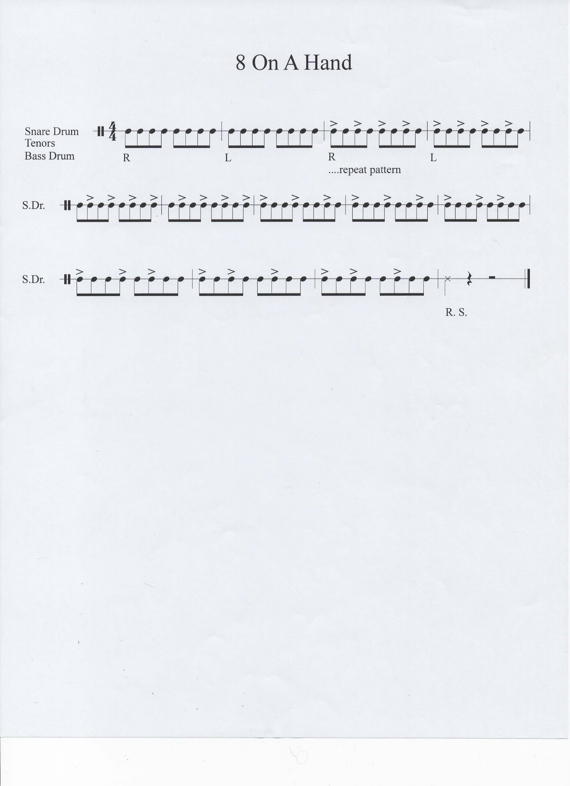
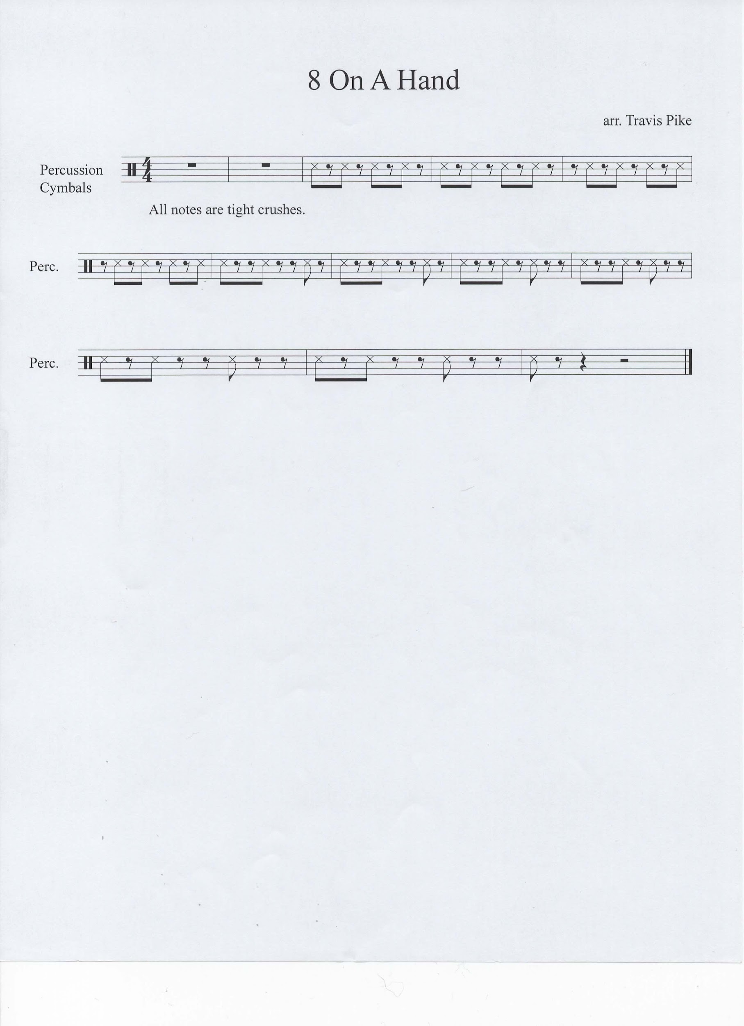
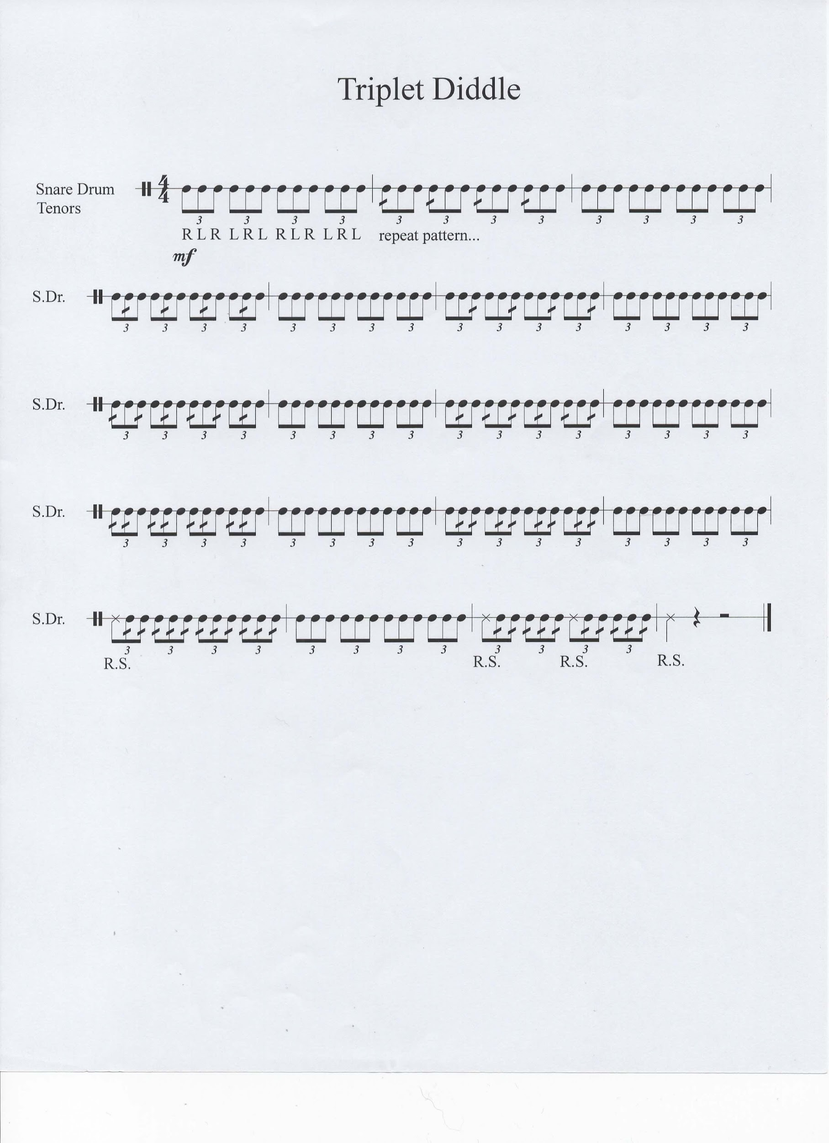
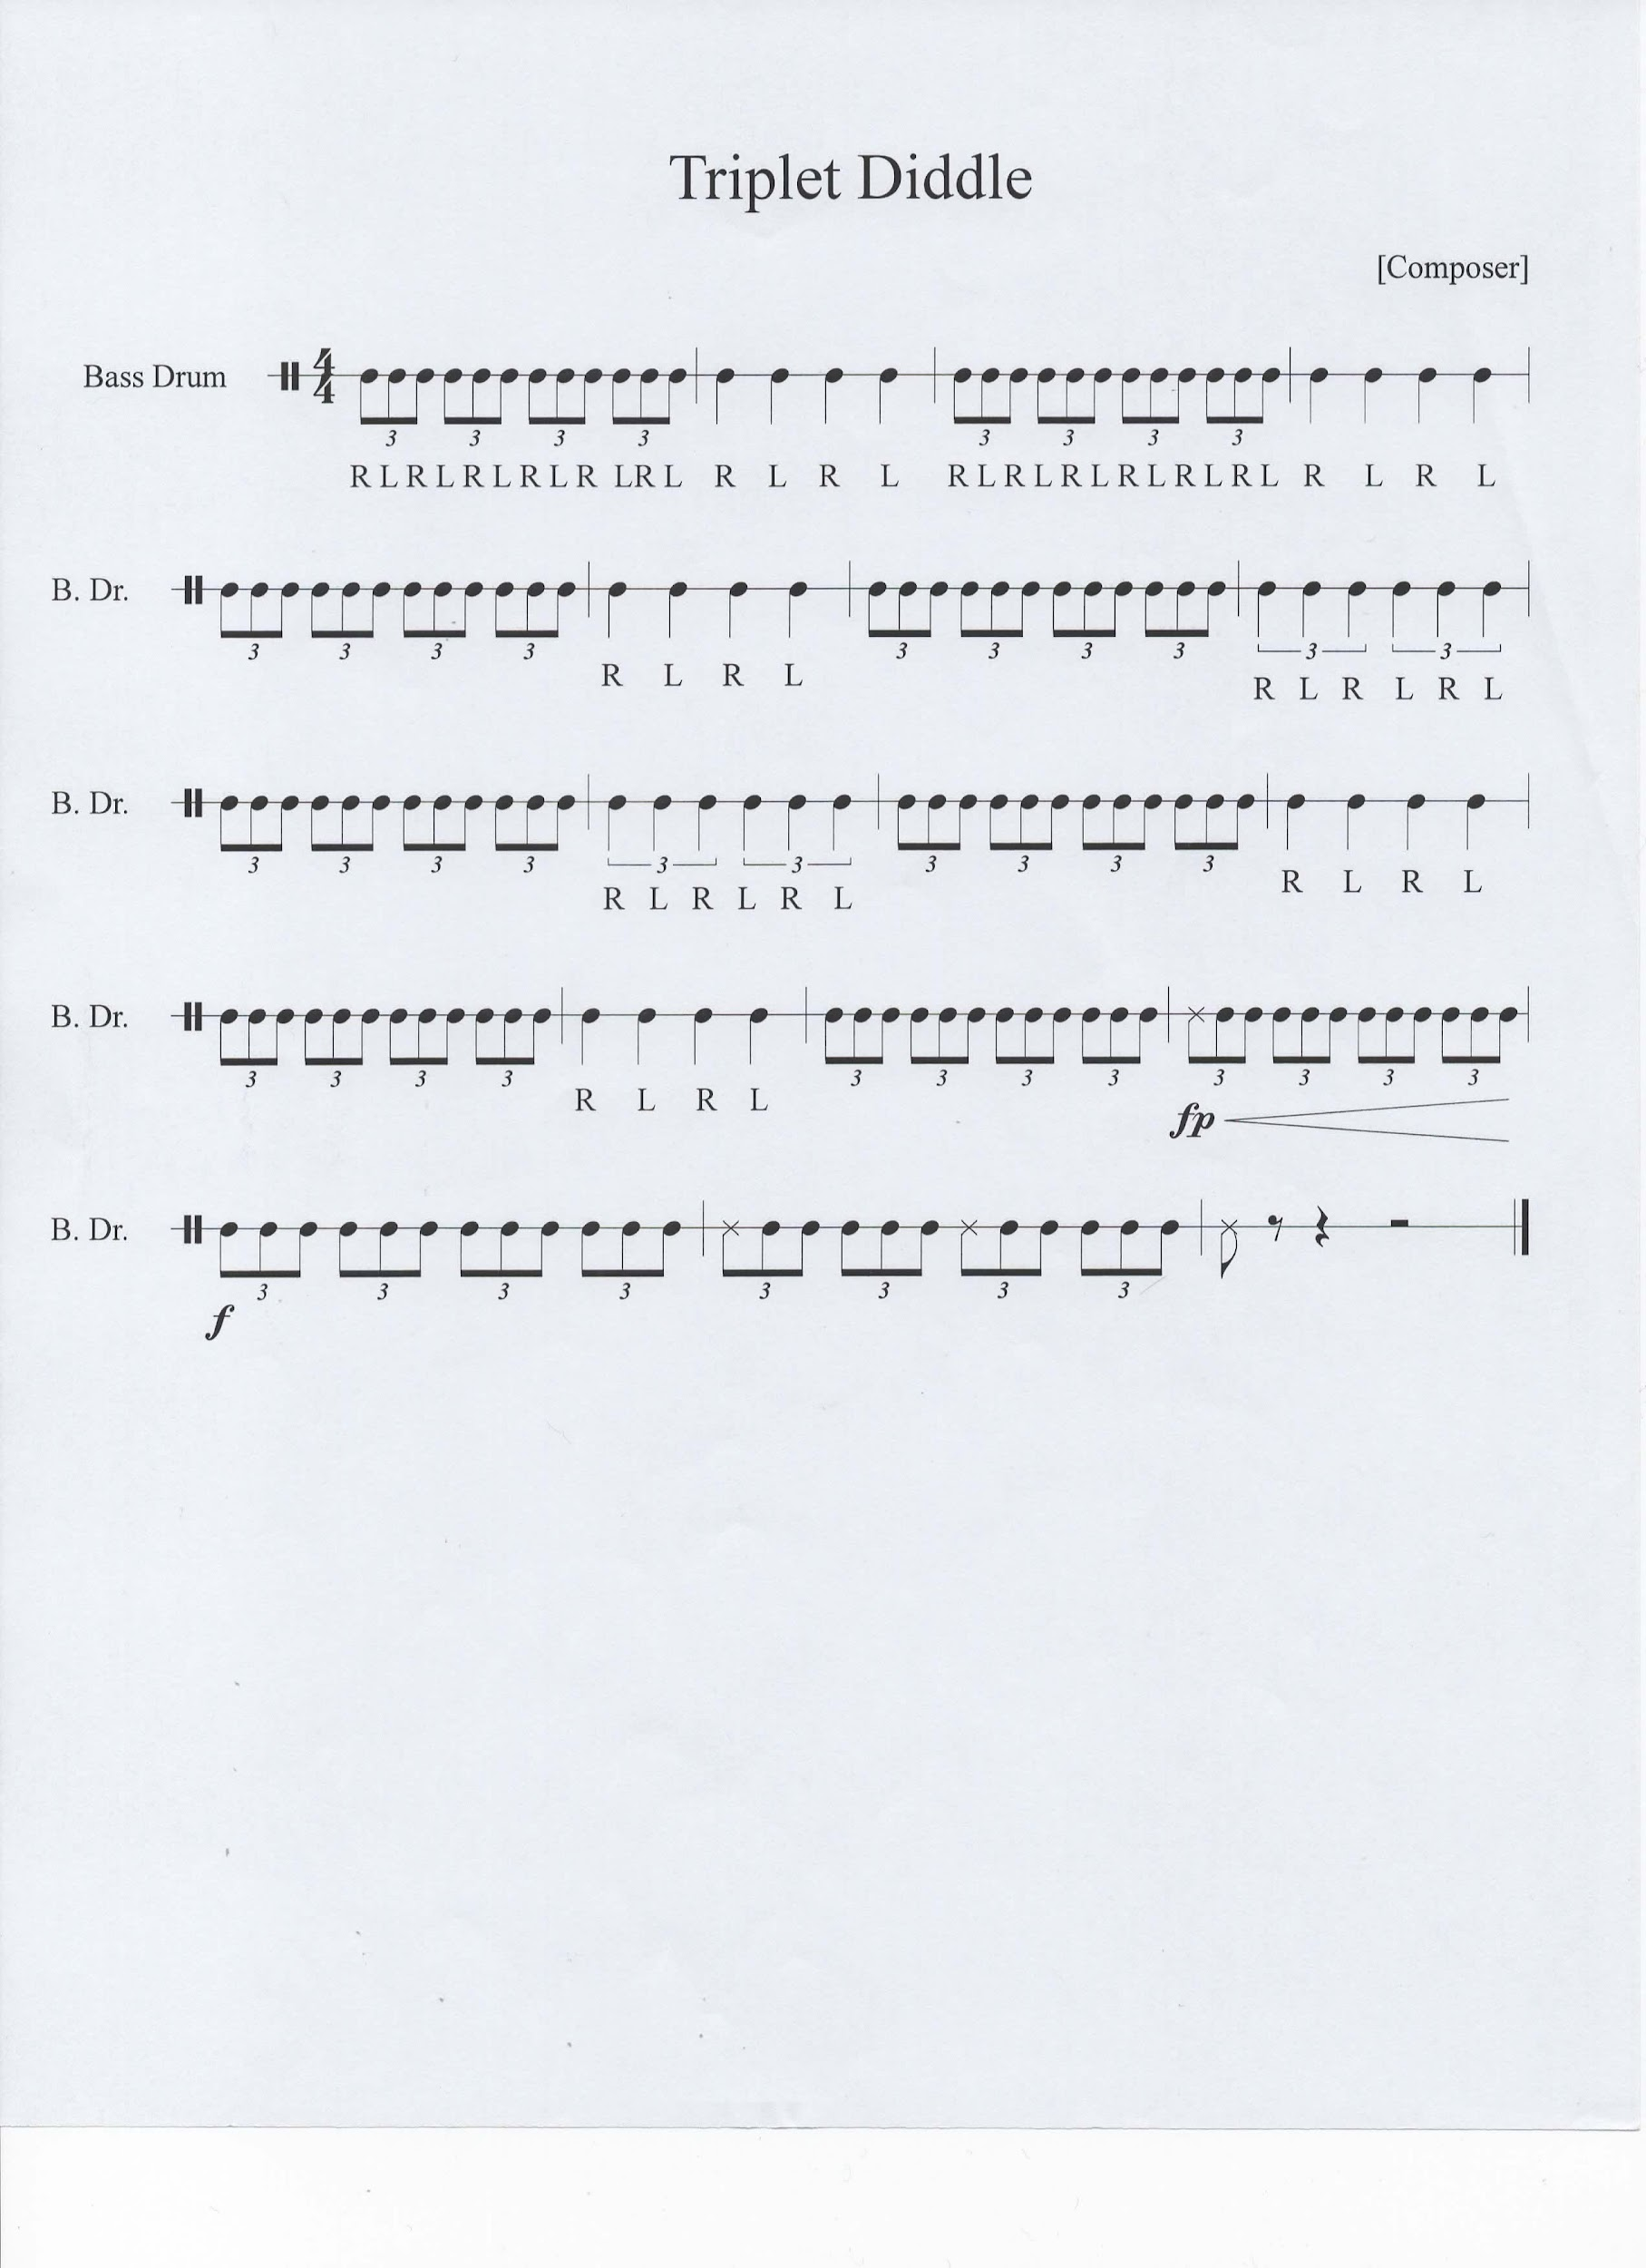
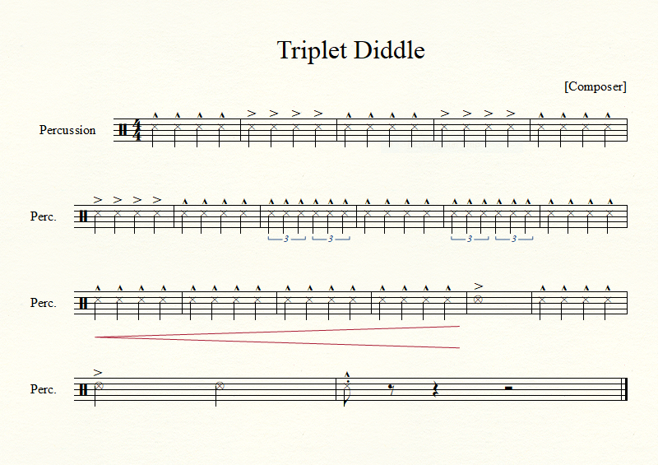

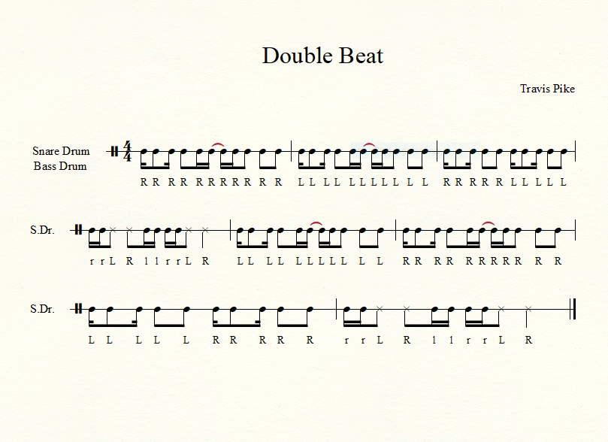
Snare - “X” = Rim Shot
Bass - “X” = Rim Click

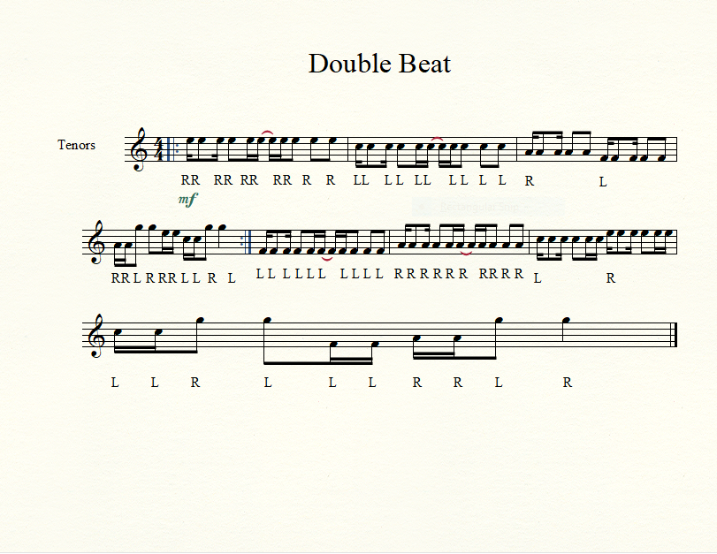

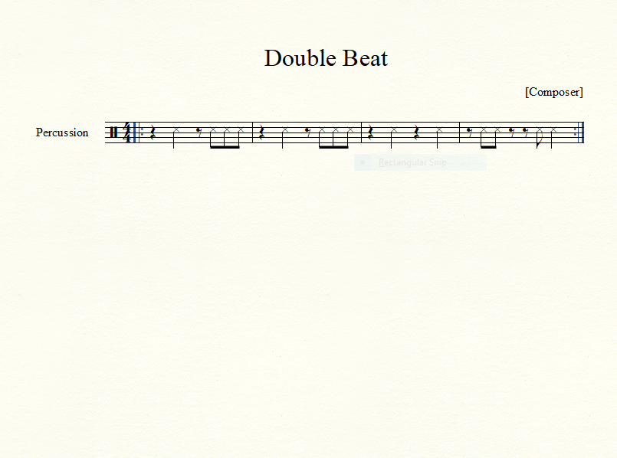
Cymbals

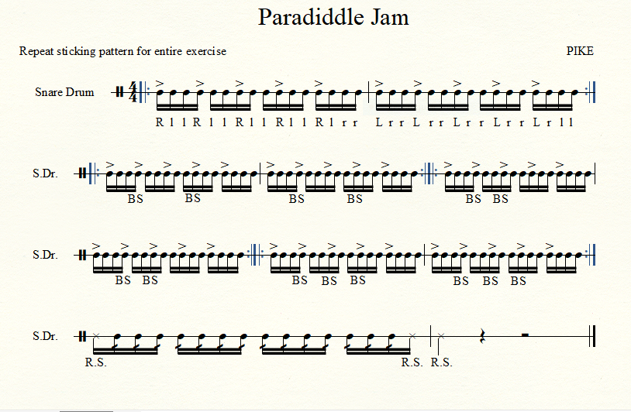
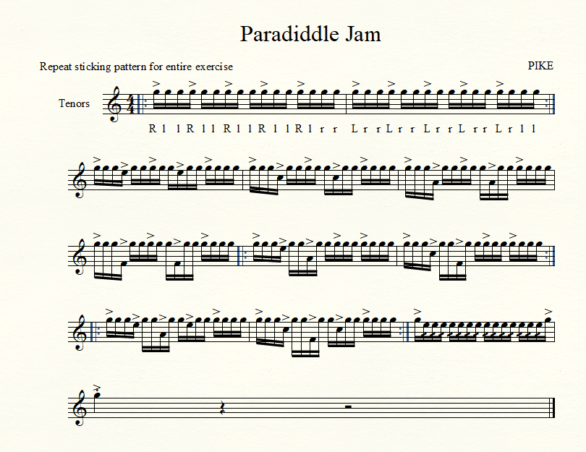
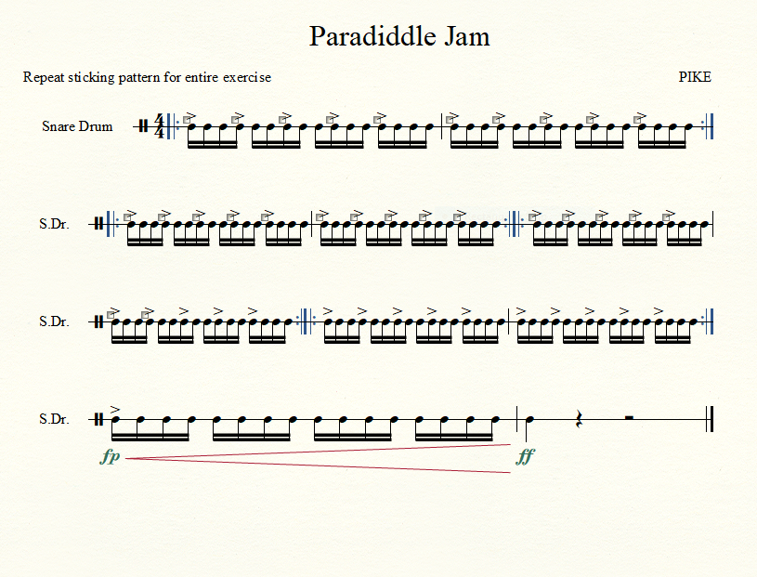
THIS IS THE BASS DRUM PART

Falcon Flams
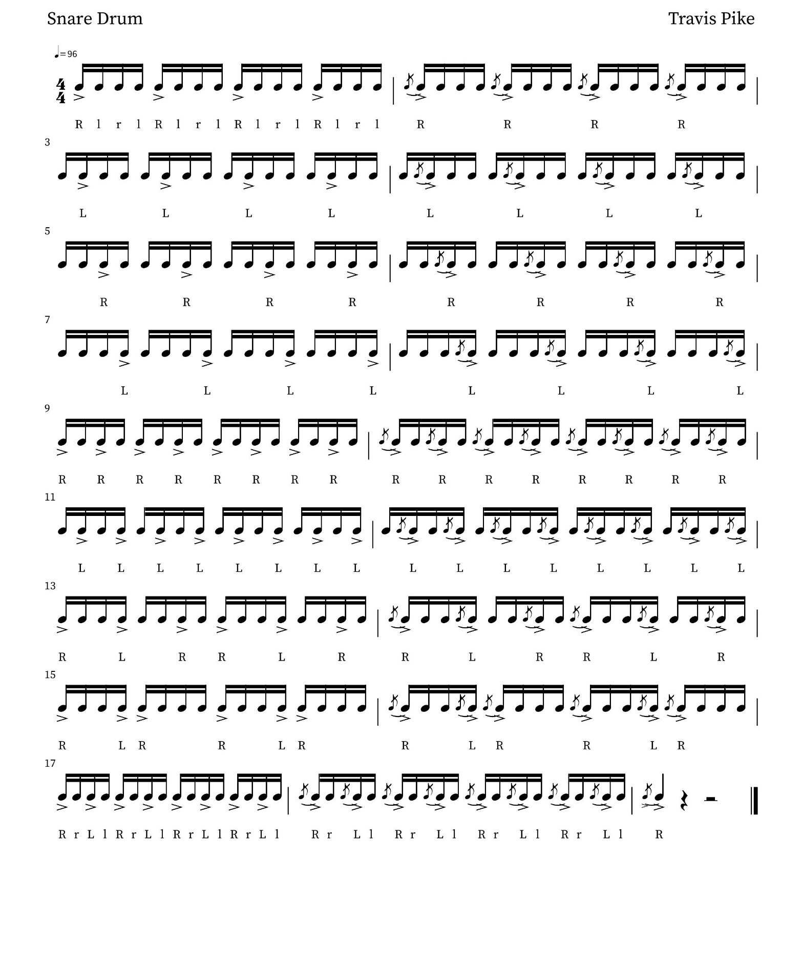

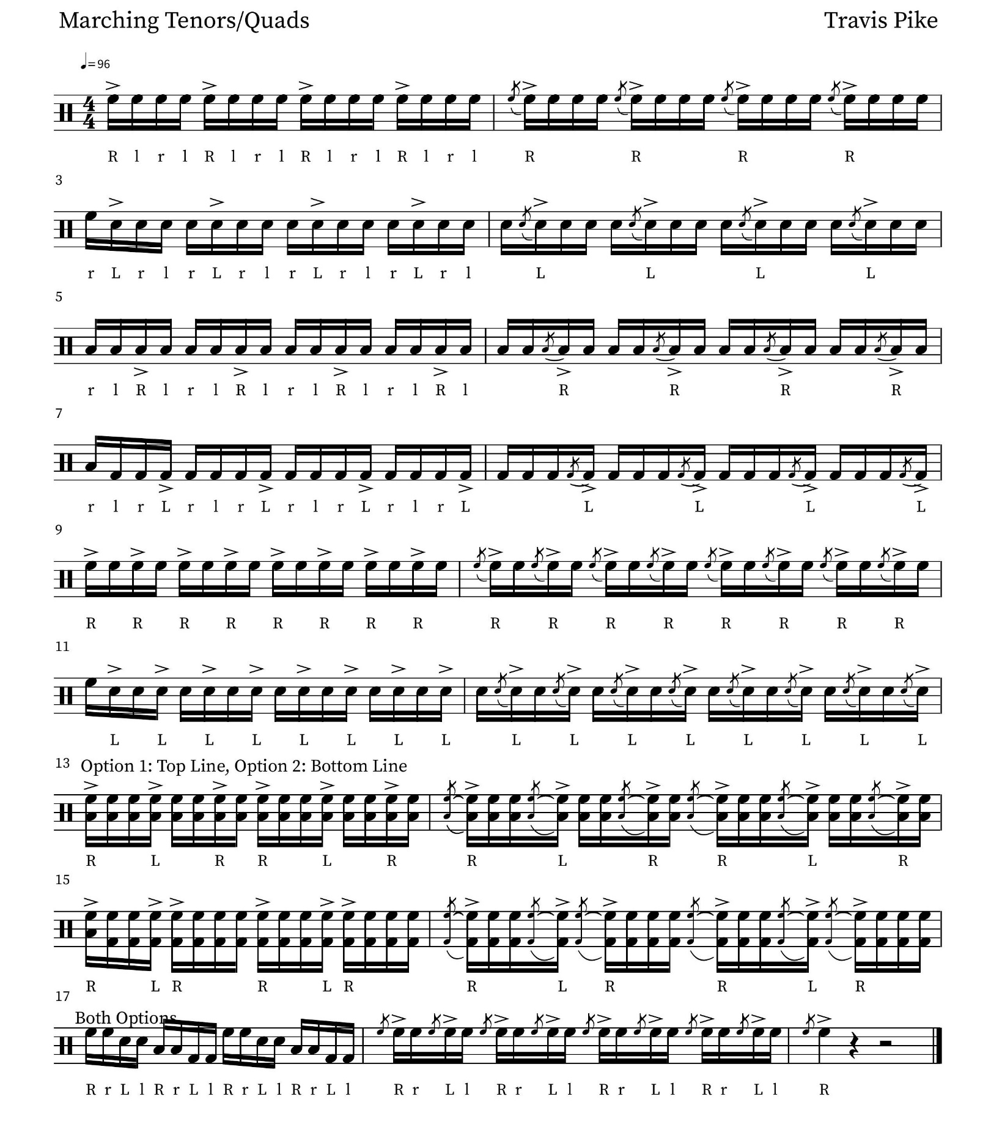
Falcon Flams

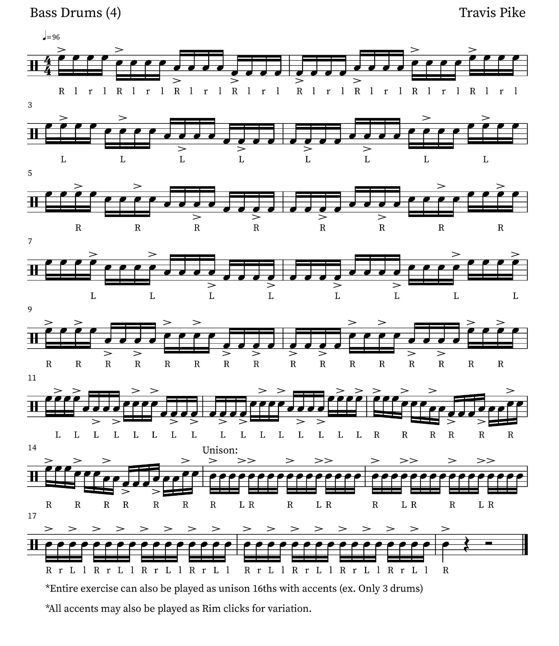
Falcon Flams

Falcon Flams
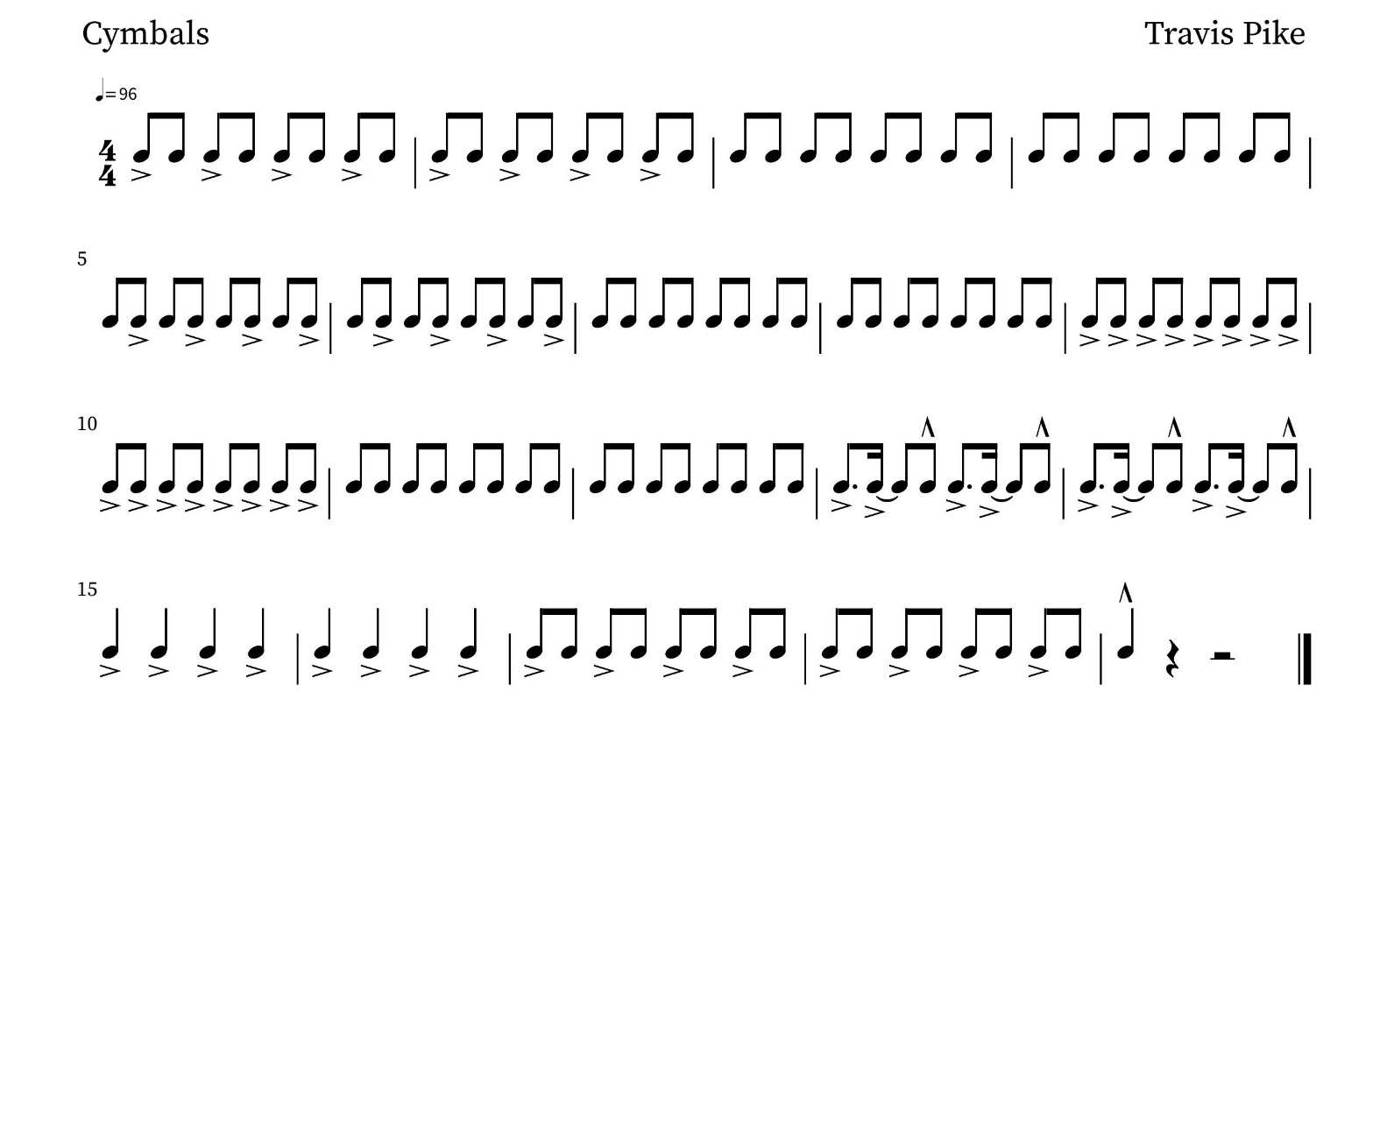

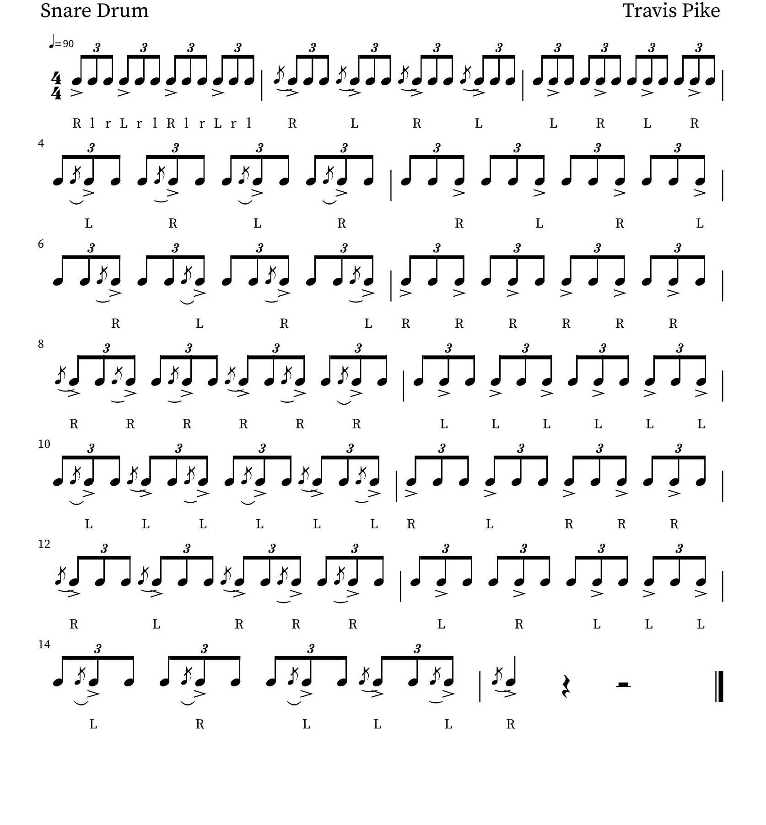
Falcon Flams II
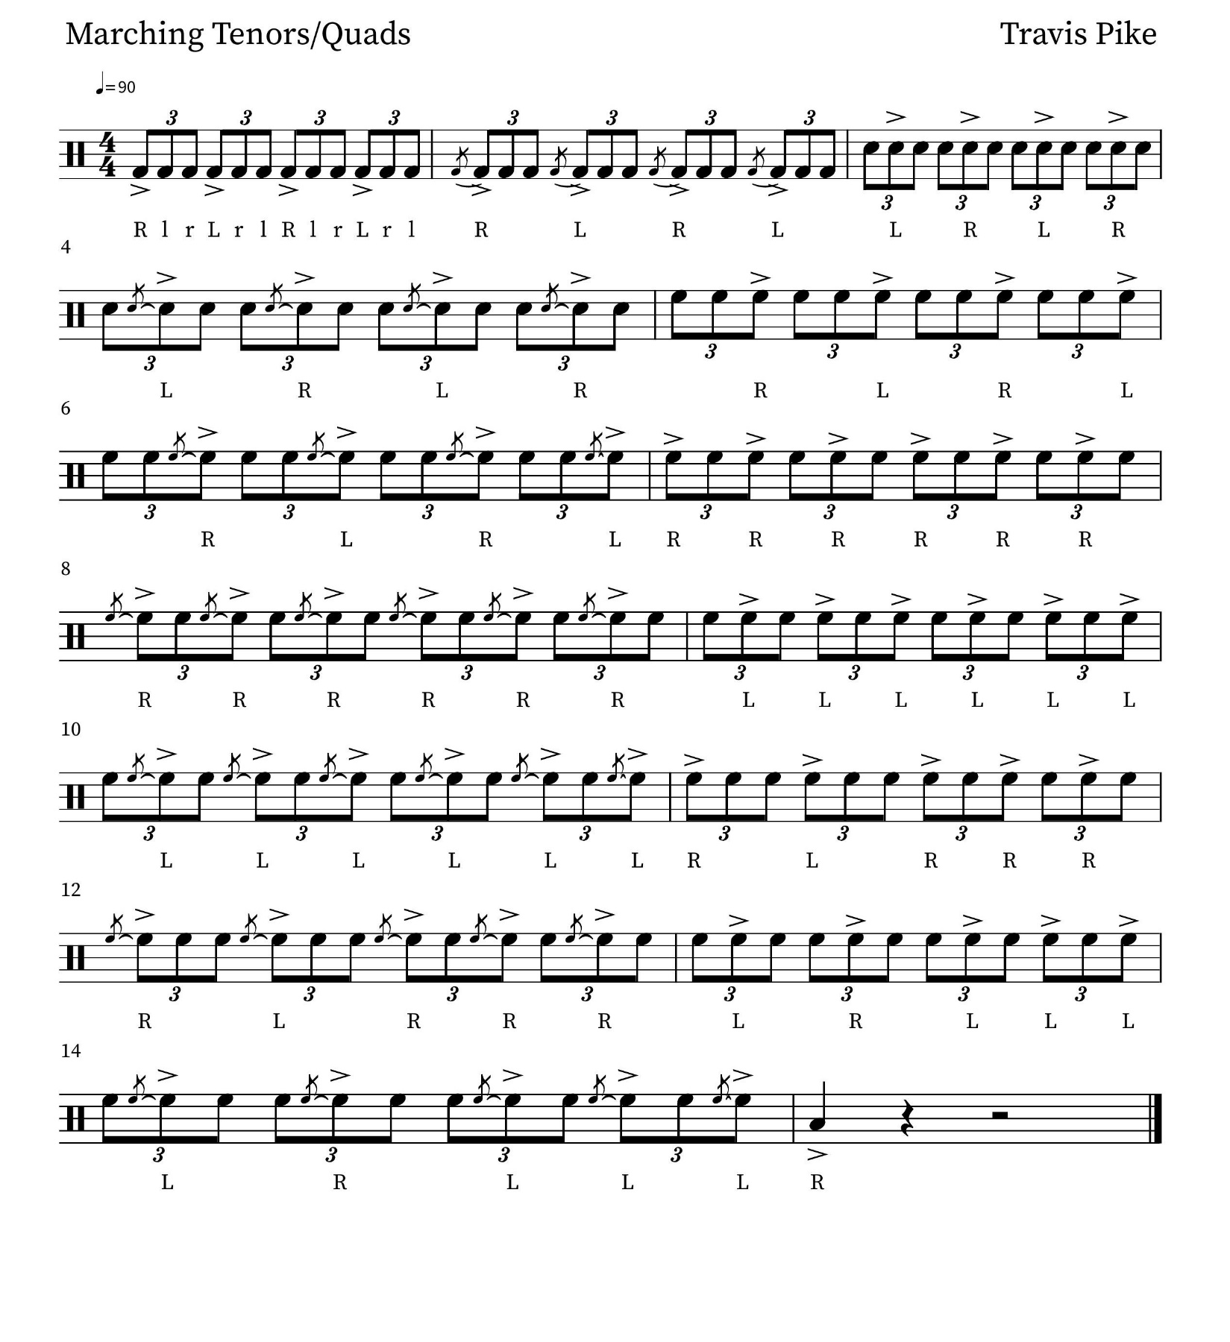
Falcon Flams II
Falcon Flams II
